Cryptography Midterm Exam 2010/04/27

Part I (3 points each)

1. Which irreducible polynomial over GF ₅ is primitive?
A. x² + 2 B. x² + x + 1 C. x² + 2x + 3 D. x² + 4x + 1 E. None of the above

2. Which multiplicative group is NOT of order 36?
A. Z₃₇* B. Z₆₃* C. Z₁₀₈* D. Z₁₂₆* E. None of the above

3. α ∈ GF₈ is a root of x³ + x² +1. Whose minimal polynomial is x³ + x +1?
A. α² B. α⁴ C. α⁴ + α² D. α⁴ + α³ E. None of the above

4. Which is NOT a finalist of the AES selection?
A. Mars B. Rijndael C. Twofish D. IDEA E. None of the above

5. For a group homomorphism f : (Z₁₆, + mod 16) → (Z₁₇*, × mod 17), which assignment of the value of f (1) makes f an isomorphism?
A. 2 B. 4 C. 6 D. 8 E. None of the above

6. Which ideal is NOT a principal ideal in the specified ring?
A. < x, y > in Z[x, y] B. < x² − 1 > in Q[x, y]
C. < 6, 15, 33 > in Z D. < x + 1, x² > in Q[x] E. None of the above

7. Which quotient ring is isomorphic to GF₆₄?
A. GF ₂[ x] / < x⁶+ x⁵+ x⁴+ x³+ x²+ x+1 > B. GF ₂[ x] / < x⁶+ x⁴+ x³+ x²+1 >
C. GF ₂[ x] / < x⁶+ x²+1 > D. GF ₂[ x] / < x⁶+ x⁴+ x³+1 > E. None of the above

8. In the “Mix Columns” operation of AES, each column is treated as a polynomial over GF ₂₅₆ and is multiplied modulo r(x) with fixed 3x³ + x² + x + 2. What is r(x)?
A. x⁴ B. x⁴ + 1 C. x⁴ + x + 1 D. x⁴ + x² + 1 E. None of the above

9. Which statement about the one-time pad (OTP) is FALSE?
A. XOR operation is often used to combine the plaintext and the key elements
B. It is information-theoretically secure with the so-called perfect secrecy
C. To be unbreakable, its key has to be truly random and never reused
D. Such system with the perfect secrecy property is widely used in practice
E. None of the above
10. Which mode of operation for decryption does the diagram below show?
A. OFB B. CFB C. ECB. D.CBC E. None of the above
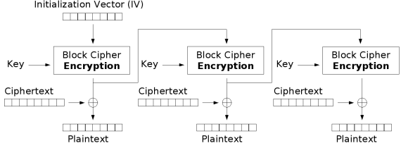

Part II (3 points each)

- x ≡ 11 (mod 12 ) is the solution to the system of congruences
2x ≡ 1 (mod 3) x ≡ 3 (mod 10) 5x ≡ 4 (mod 67)

- To prove that x is a generator of the multiplicative group Z₆₃*, it is sufficient to show x^{m} ≠ 1 and x^{n} ≠ 1 where 0 < m < n. We have (m, n) = ( 13 , 14 ).

- GL₃(Z₇) is the group of invertible 3 × 3 matrices with entries in Z₇, and SL₃(Z₇)
is its subgroup consisting of the matrices with determinant 1. Their group orders are | GL₃(Z₇)| = 15 and | SL₃(Z₇)| = 16 .

- In the multiplicative group (Z₆₅*, ×):
- 17⁻¹ (the multiplicative inverse of 17) = 17 .
- o(3) (the order of 3) = 18 .

- Since P ( x ) = x⁵ + 2x + 2 is irreducible over GF₃ , the quotient ring
K = GF₃ [x] / (P ( x )) is a finite field. Let Q ( x ) = x² + 2x + 1.
- The number of elements in K is | K | = 19 .
- Q ( x ) ¹²¹³ = 2x³ + 20 in K.
- Q ( x ) ⁻¹ = x⁴ + 21 in K.

- Complete the table:
Block cipher | Block size (bits) | Key size (bits)
Triple-DES | 64 | 112 or 22
IDEA | 64 | 128
AES | 128 | 128, 192, or 23
SMS4 | 24 | 128

- 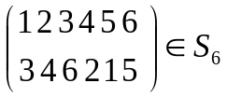Applying the secret permutation on the plaintext CRYPTO, we
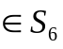obtain the ciphertext TPCROY. Suppose the permutation σ is applied on CRYPTO to obtain POCTYR, then σ ² = 25 and σ ⁻¹ = 26 .

- Consider the affine cipher c = mp + s mod 50, where c and p denote the ciphertext and the plaintext respectively:
- The size of its key space (possibilities of (m, s)) is 27 .
- Given the encryption formula c = 7p + 11 mod 50, the corresponding decryption formula is p = 28 mod 50.
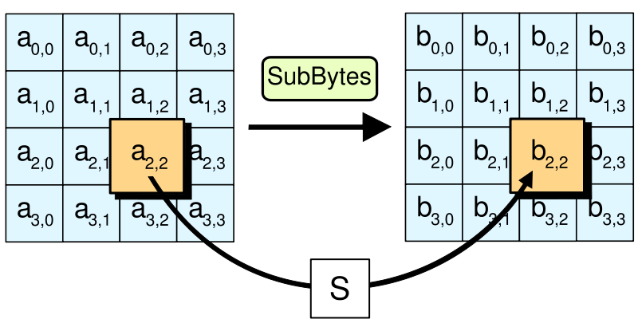
- The S-box of AES is constructed as follows.
- a_{i,j} → a_{i,j}⁻¹ → b_{i,j}
- a_{i,j} × a_{i,j}⁻¹ = 1 (mod x⁸+x⁴+x³+x+1) but 0 ⁻¹ = 0
- Affine transformation: a_{i,j}⁻¹ → b_{i,j}
b_{i,j}
a_{i,j}⁻¹
- 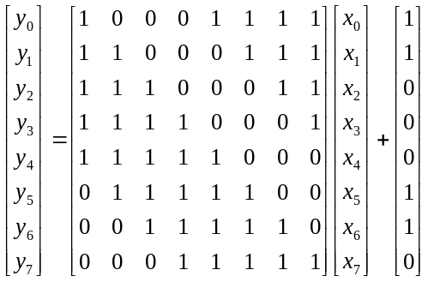Complete the last mapping:
    - 00000000 → 00000000 → 01100011
    - 00000001 → 00000001 → 01111100
    - 00000011 → 29 → 30

Part III (Write down all details of your work)

31 (4 points) Find integers a and b such that 31a + 53b = 1.

32 (6 points) Explain why a block cipher of Feistel structure has the same algorithm for both encryption and decryption.
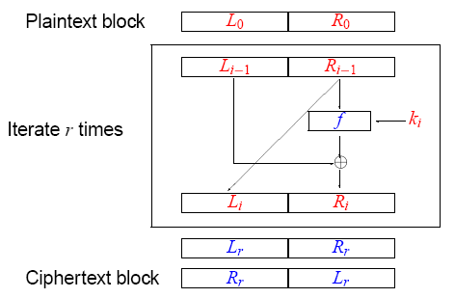
Cryptography Midterm Exam 2010/04/27
Name: ____________ Student ID number: ____________

1 | 2 | 3 | 4 | 5 | 6 | 7 | 8 | 9 | 10
11 |  | 12 |  | 13 |  | 14 |  | 15
16 |  | 17 |  | 18 |  | 19 |  | 20
21 |  | 22 |  | 23 |  | 24 |  | 25
26 |  | 27 |  | 28 |  | 29 |  | 30

31

32
Cryptography Midterm Exam 2010/04/27
Solution
1 | 2 | 3 | 4 | 5 | 6 | 7 | 8 | 9 | 10
C | E | C | D | C | A | E | B | D | A
11 |  | 12 |  | 13 |  | 14 |  | 15
443 |  | 2010 |  | 12 |  | 18 |  | (7³−1)(7³−7)(7³−7²)
16 |  | 17 |  | 18 |  | 19 |  | 20
7² (7³−1) (7³−7) |  | 23 |  | 12 |  | 243 |  | x² + x + 1
21 |  | 22 |  | 23 |  | 24 |  | 25
2x³ +2x² + 2 |  | 168 |  | 256 |  | 128 |  | (15)(34)
26 |  | 27 |  | 28 |  | 29 |  | 30
(1453)(26) |  | 1000 |  | 43(c − 11) |  | 1111 0110 |  | 0111 1011

31 a = 12, b = −7

32

